Data Engineer / Scientist Business Case

We expect this task to take approximately 6–8 hours to complete for a strong candidate.
We appreciate that candidates will have different levels of familiarity with healthcare data, so if you need additional time due to other commitments or would like to discuss an extension, please let us know.
We are primarily assessing your ability to create
- Clear, reproducible Python work
- Correct use of the API and indicator definitions
- Sensible data validation and handling of assumptions
- A clear, evidence-based business recommendation
We are not expecting
- Prior pharma or CKD expertise
- Production-grade engineering
- Extensive visualisation or slide design
Although the brief is 9 pages long, most of it is background and supporting context intended to help you; the core task itself is much narrower.

Background
Chronic Kidney Disease (CKD) is a long-term condition in which the kidneys gradually stop working as well as they should, often with few or no symptoms at first. This means many people are diagnosed late, when damage is harder to reverse and the risk of serious complications is higher. There is therefore a significant unmet need for earlier detection, better ongoing monitoring, and treatments that slow progression and reduce the burden on patients’ daily lives.
Boehringer Ingelheim is launching a new product in the treatment of Chronic Kidney Diseases. The key priority for the business is to help the NHS to identify as many CKD patients as possible, to prepare the market before the product is launched, so that we can maximise the chances for the patients to have access to the newest medication for their diseases.
Patient’s pathway for accessing treatment may be summarised in the following steps:
- Tests: Eligible patients can receive tests which would indicate they potentially have CKD. They key tests are
  - eGFR (measures how well the kidneys are filtering waste from the blood)
  - urine ACR (measures how much protein is leaking into the urine)
- Diagnosis: Patients who has test results indicating they have CKD have been correctly diagnosed and coded into the NHS system by their GPs. Generally speaking, in the UK, doctors only diagnose patients when they reach CKD disease stage (G3a to G5). G-numbers indicate how low their eGFR readings are:
  - >90 is G1 (Good health),
  - 89-60 is G2
  - 59-45 OR uACR > 3 is G3a (patients needs to start treatment per NHS guidance),
  - 44-30 is G3b
  - 29-15 is G4 (severely ill)
  - < 15 is G5 (end stage of disease, patients need dialysis or kidney transplant to live).
For this exercise you do not have to worry about these fine details, you just need to know that (G3a and above) means a patient has CKD that requires treatment.
- Treatment: Patients who has been diagnosed with CKD are put on treatment
For this exercise, we want to use data to help the business to understand how we can prioritise our efforts in the improvement of both the Testing and Diagnosing of patients, so that we could maximise the number of patients eligible for our product at the time of its launch in two years’ time.

Data
The NHS in England regularly publishes audit findings of clinical performance in the monitoring and treatment of key diseases, including CKD, in what is known as the CVDPrevent audit. The audit data is open to the public, and can be accessed through:
https://www.cvdprevent.nhs.uk/
The audit data contains findings on the NHS performance on a number of high-risk diseases. Not all of them are relevant for this exercise.
The datasets relevant for this exercise are specifically:
- CVDP001CKD: Prevalence of GP recorded CKD (G3a to G5)
- CVDP002CKD: Patients whose last two eGFRs are less than 60ml/min/1.73m2 (uncoded CKD), who do not have a record of GP recorded CKD (G3a to G5) --- i.e. undiagnosed patients.
- CVDP004CKD: Patients with GP recorded CKD (G3a to G5) with a record of a urine ACR test in the preceding 12 months
- CVDP006CKD: Patients with GP recorded CKD (G3a to G5), with a record of an eGFR test in the preceding 12 months
The dataset is also segmented based on level of geographical granularity. For this exercise, we only focus on the ICB level.
An ICB, or Integrated Care Board, is an NHS England authority that covers a particular region of England. They are the top governing body for NHS in a particular region. Typically, one ICB covers one city, or county, and for large cities like London there can be several ICBs covering different parts of it. For this exercise, we assume the business wants to have different strategies for improving testing and diagnosis at ICB level.

Exploring data (to help you further understand the data structure and meta data)
For each data set, you can explore it using the data explorer from the CVDPRevent main page
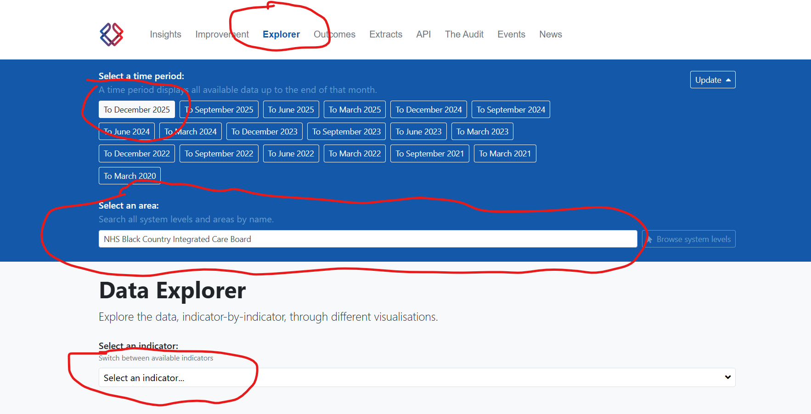
Then for indicator --- i.e. a specific data set, select the ones that are relevant:
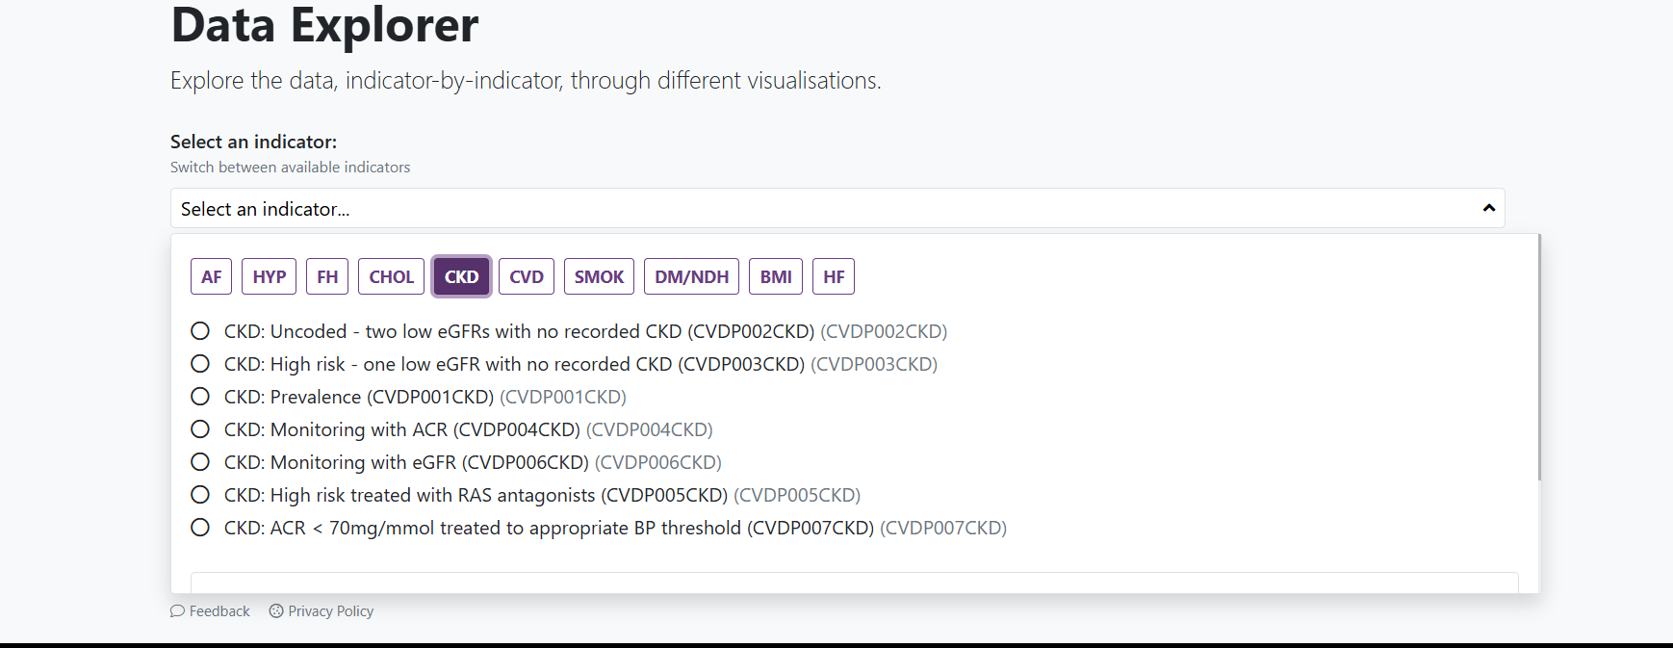

For example, select CKD:Prevalence (CVDP00CKD), then click on Data Extract (.csv) will allow you to see the raw data
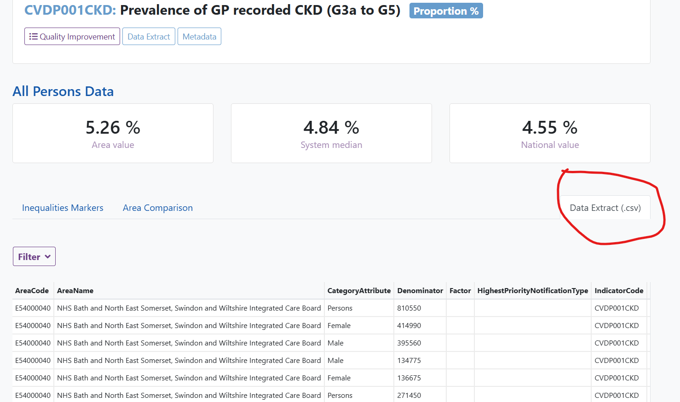

For all of the data sets of interest to us, the tables will always contain columns:
- Denominator: The size of the base population used by each data set
- Numerator: The size of the population from which the performance indicator is calculated. And the performance is depicted as a % value = Numerator / Denominator.
Please note that the definition of Denominator and Nominator changes for each indicator data set. E.g
- Denominator for CVDP001CKD is the total population of an ICB
- Numerator for CVDP001CKD is the number of patients diagnosed with CKD
- Denominator for CVDP002CKD is the total patients with eGFR test results that makes them eligible to be diagnosed with CKD
- Numerator for CVDP002CKD is the number of eligible patients who has not been diagnosed with CKD --- i.e. the proportion of patients that are underserved by the NHS
To understand the meaning of denominators and numerators for the data sets, you can click on ‘Metadata’ in the Data Explorer, and it will provide detailed description of what they are measuring:
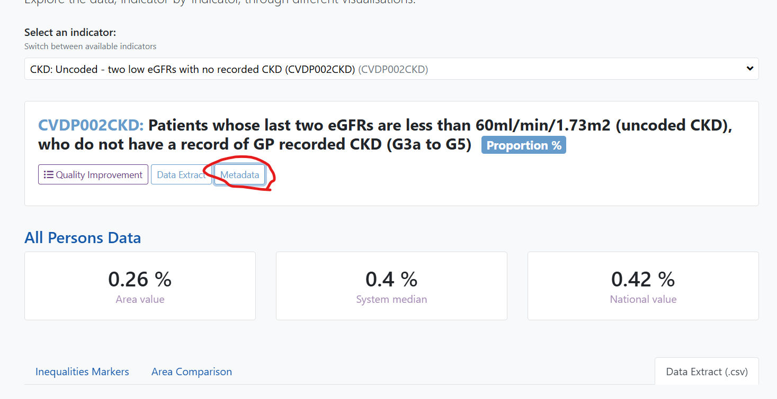
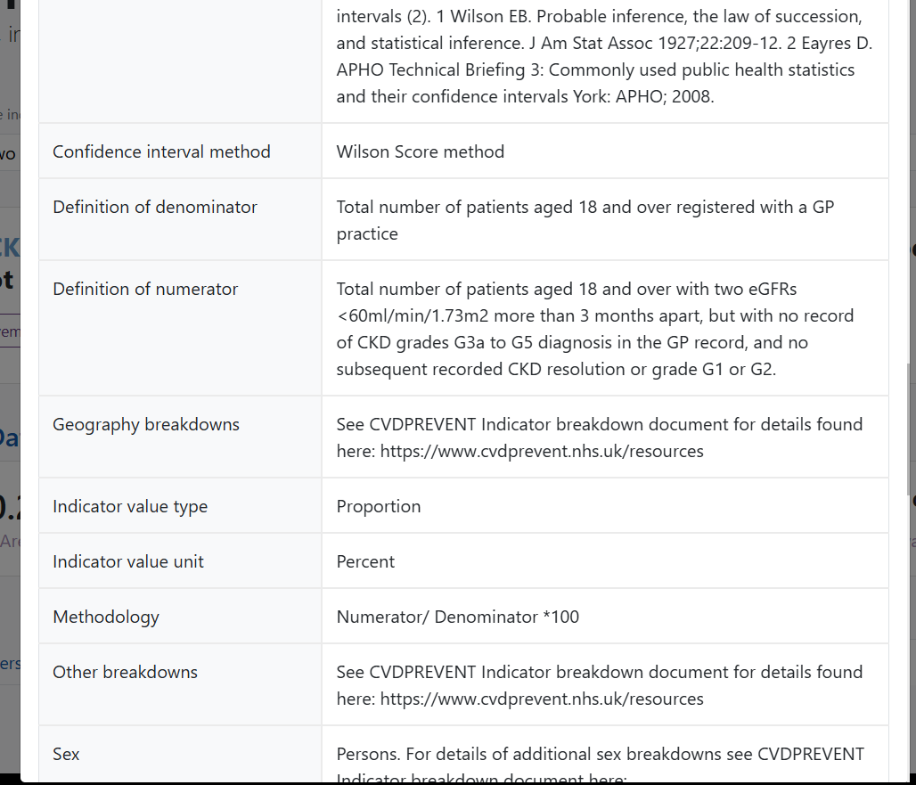

The API
CVDPrevent provides an API for automated data extraction. Documentation for it is provided here
CVDPREVENT API Documentation - CVDPREVENT (Public) - Confluence
As part of the exercise, to help saving time, we also provide you with a list of ID codes you will need to query the API. These are included in the excel file called ‘CVDP API Codes’.
The Data Explorer also helps you to find the correct query parameters, as it uses the same query format, albeit with slightly different parameter names. E.g.
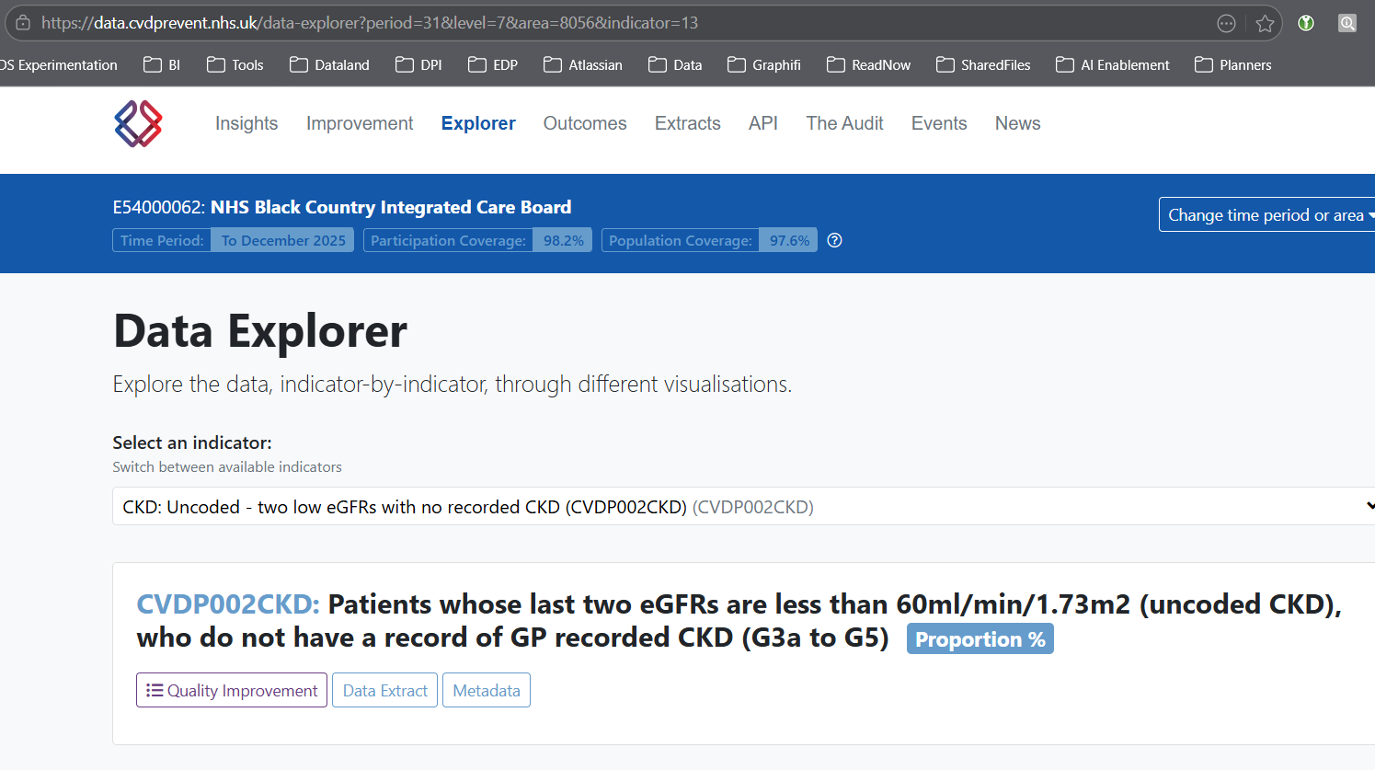
The URL will show you that, to get CVDP002CKD data broken down at ICB level for period up to December 2025, you need to use parameters
- timePeriodID = 31 (to December 2025)
- SystemLevelID = 7 (ICB)
- indicator = 13 (CVDP002CKD)

Task

The output should be provided as
- one main reproducible ipython/jupyter notebook showing your work and answers, including any plots
- any supporting .py or any other supporting files you have created
- For both the notebook and python codes, sufficient comments with explanations to allow the interviewer to understand your work
The task:
- Create a python code that utilises the CVDPrevent API to extract data, the output must be a Pandas data frame that contains following columns
  - ICB
  - Time Period
  - N total Population
  - N patients eligible for diagnosis of CKD
  - N patients eligible but uncoded
  - N patients eligible for EGFR tests
  - N patients tested for EGFR
  - N patients eligible for urine ACR tests
  - N patients tested for urine ACR

HINT: the API should be relatively straightforward using the standard python library ‘requests’, we expect the code be relatively simple, no more than 100 lines. You do not have to spend too much time on efficiency, but you do need to consider data quality, making sure you are not outputting wrong data or duplicates.

- Use the data frame you have constructed, provide the following analysis to answer the business questions:
  - Which ICBs have the biggest potential market for CKD? Rank them.
    - There is no single correct ranking method; we are interested in your reasoning, assumptions, and how well you support your recommendations with data.
  - Which ICBs should have the biggest investment from Boehringer to getting more patients diagnosed, and explain your rationale using data evidence?
    - Consider that business would probably not be interested in investing in ICBs with low market potential, even if they have poor diagnostic rates for CKD
    - Uncoded = undiagnosed
  - For the priority ICBs, what would be the focus on testing strategies to improve diagnosis rates, again explain your rationale with data?
    - E.g. should we be focusing on eGFR tests, or uACR tests, or both?

Bonus (not necessary for a strong submission) will be given to candidates who want to a bit of challenge and go a bit further in the analysis, by incorporating any additional data provided by CVDPrevent, e.g. (just as a suggestion) have you considered:
- The dynamic nature of the ICB behaviours, are they already improving their coding and testing rates?
- Can you create customer segments using unsupervised machine learning?
- Do gender or age play a role in your findings?

Please make sure that your solution notebook submitted could be run by the interviewer --- i.e. include a requirements.txt file for your python environment if you are using any non-standard libraries for your solution.
We expect that for this solution, you would unlike need any libraries outside of:
- pandas, numpy, scikit-learn
- standard libraries like ‘requests’
But if you do want to use any exotic libraries, please feel free to do so as long as you list them in your requirements.txt.

